Python Assignment
Name – Ashwini Amit Gund
Roll no – 2601072

Q1. Write a program to read a file and count how many vowels are present in its content.

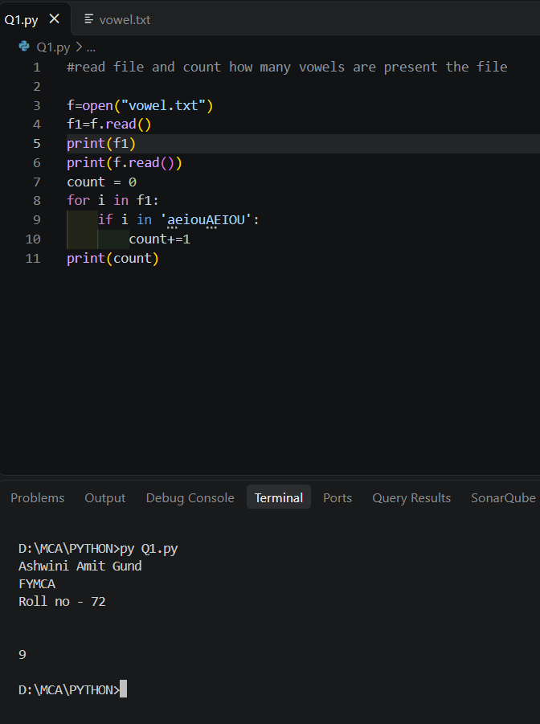

Q2. Read all lines from a file into a list. Print the total number of lines and display the 2nd and 4th line.

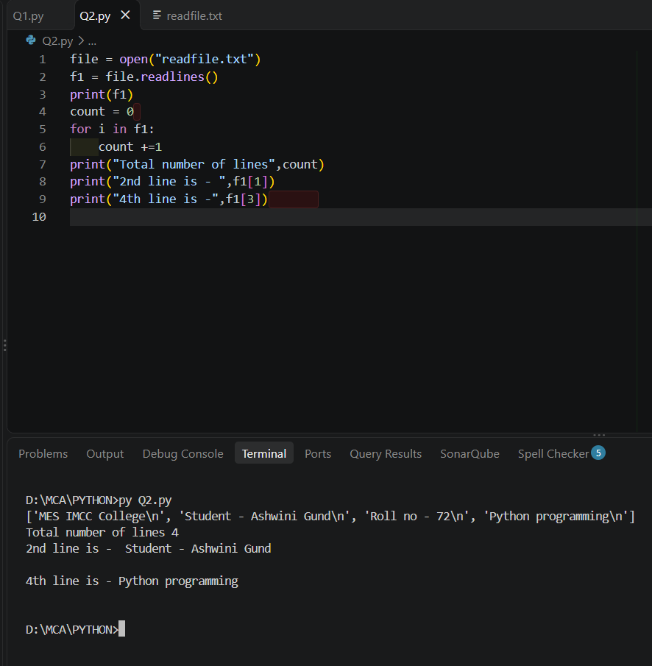

Q3. Take a sentence from the user, split it into words, and store them in a list. Print the longest word.

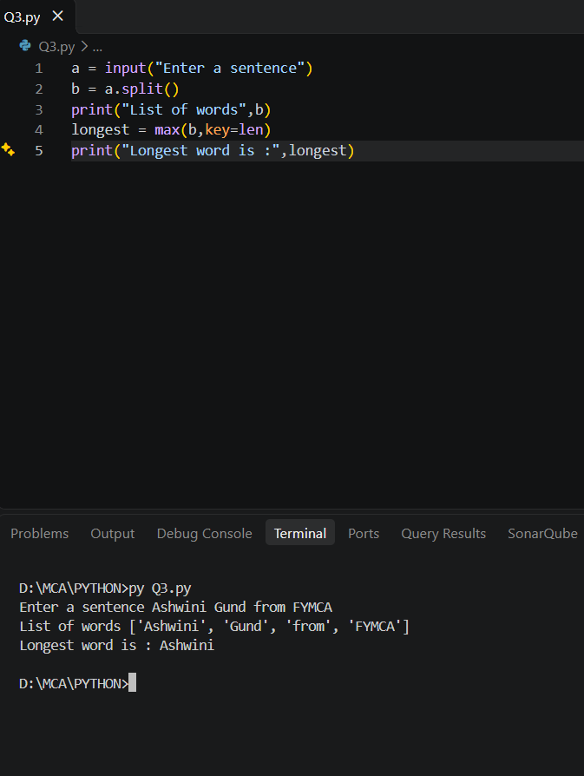

Q4. Read a file, split its content into words, and store them in a list.
    - Print the total number of words.
    - Print all unique words.

